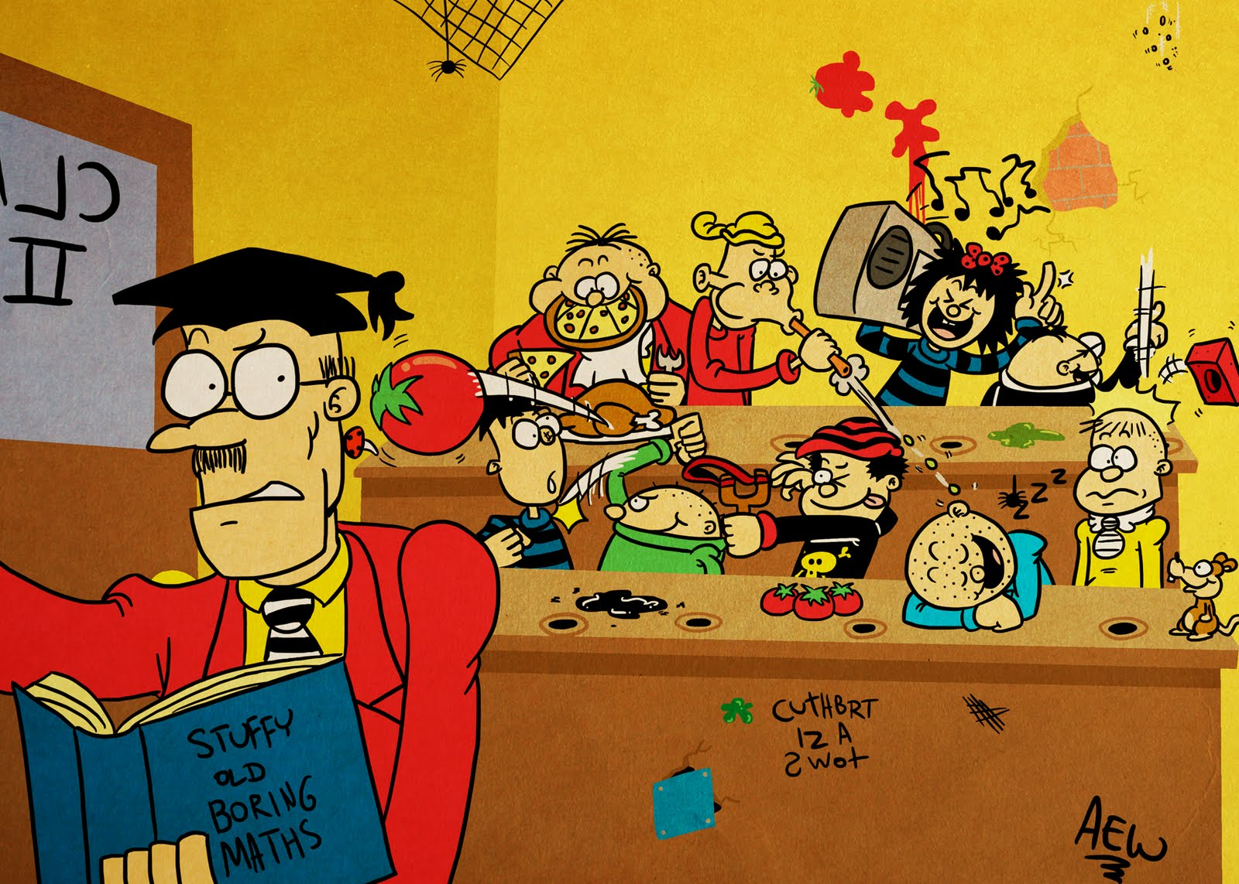

* What behaviours can you identify?
* What is the point of such behaviour?
* Why is such behaviour allowed to happen?
* Why is the teacher ineffectual in this case?
* How and why might the teacher react defensively here?
* How could the teacher deal proactively with the issue of behaviour?
* Look at the picture again. What is missing? What doesn’t it show?
* Whom do you blame for the scene in the picture?
* What do we learn about behaviour management from this picture?
* As a teacher, what would you do differently if you taught this class later the same day? How? Why?